**GoogleFu**

1. What was your search topic? How were your results different in each search engine? Which search engines did you use?

Barack Obama. Similar news, but differently titled headlines. All had his bio on the right side of page. Google, Yahoo, Bing.

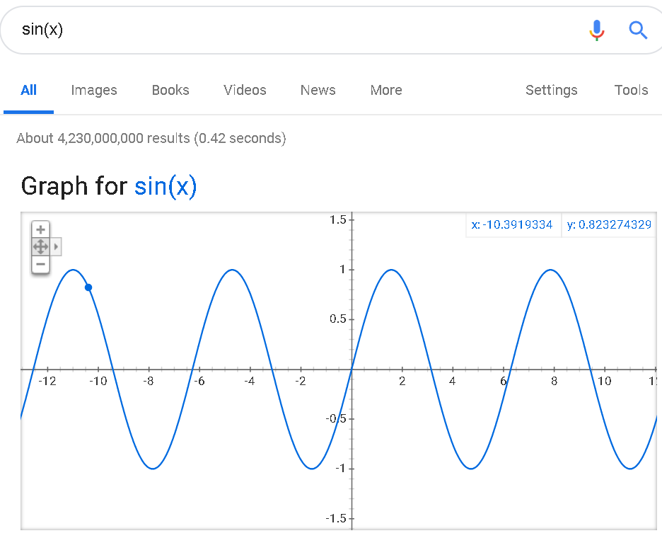2. Search google for "sin(x)" and take a screenshot of the result.

3. What did you try converting? Did it work well?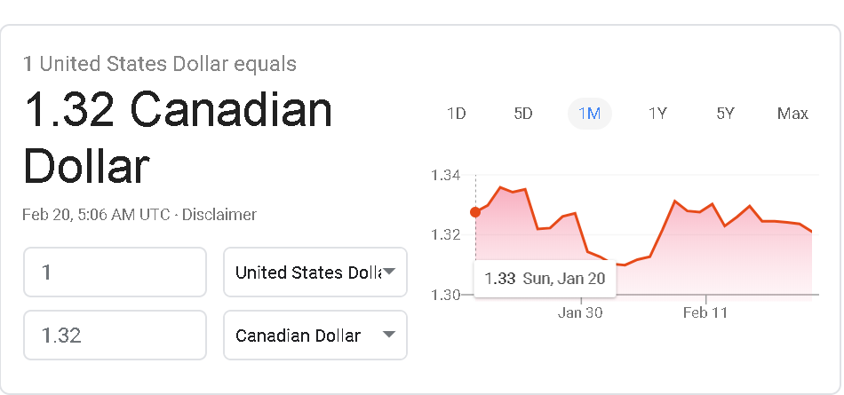

USD to CAD. Yes, it worked well.

4. How did you find your easter egg besides tilt? What was it?

Previously known. Zerg Rush.

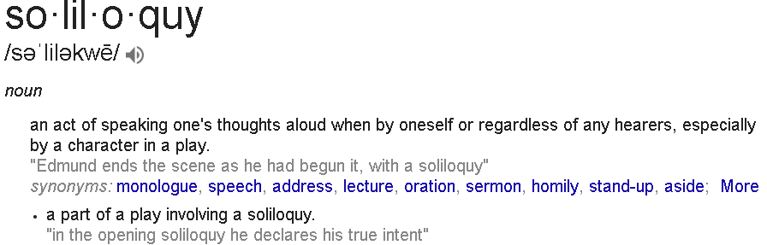5. What word did you pick? Did "define:" work?

Soliloquy. Yes, it did.

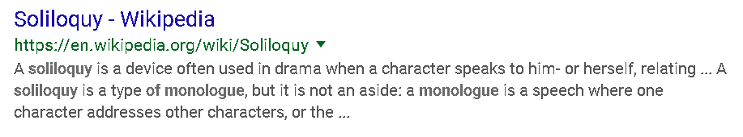6. Try keyword site:sitename.com to search your original search term on wikipedia. For example my term was Computer so I would type in computer:wikipedia.org

7. Which game did you pick? What did you think of it?

Solitaire. I thought it was set up well and gave similar options that most solitaire applications give the player.

8. Do you think Google is going downhill from its place as king of searching? Are you comfortable with the privacy policy changes?

I do not believe google is going downhill as it remains the primary search engine. I feel like most websites are acting similarly. If google doesn’t collect our information another one will. Google is attempting to be more transparent in those regards.

9. What is a Google Hack? Why might this be useful?

Computer hacking technique that use google search and other google applications to find security holes in websites.

10. What did you find about yourself? How would you get rid of information once it's online?

I found all my social media accounts and numerous photos. Also, found my father’s information such as: age, relatives, previous address, phone numbers, and emails.

Deleting all online accounts and turning off location.

11. What is Google Scholar? What topic did you pick? What did you find?

Allows user to search scholarly literature. I choose the moon landing. I found books and articles on the moon landing hoax.

12. What was the results of your image search? What image did you pick? Where did it come from?

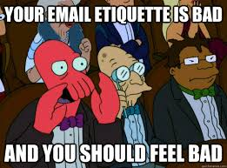The result of the google image was the same image and other variations of the image.

Week 3 power point.